Subject

Computer Vision
Activities in class
Unit I
Digital Image Fundamentals
Session 02

Teacher: Rubén Ferreiroa

- First Hour (50 min) - Theoretical Foundations:
- Participatory lecture on image formation and digital representation
- Interactive discussion on basic principles
- Q&A session to verify understanding
- Second Hour (50 min) - Practical Introduction:
- Hands on OpenCV:
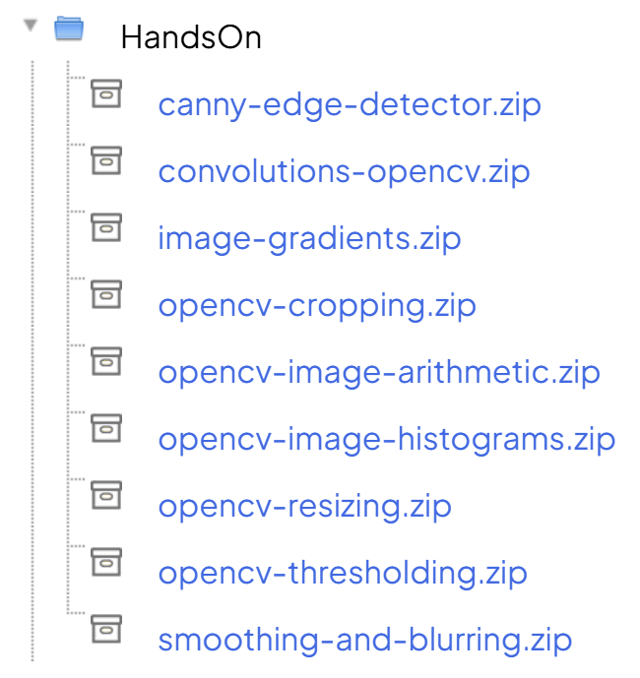
Students replicate examples on their computers and will perform parameter variations to understand the concepts.
- Third Hour (50 min) Problems:
Start solving problems in groups that will be delivered next week.


